Practical: 1

Aim: To study and implement input and output operations in the C programming language using standard library functions.

#include <stdio.h>
int main() {
int num;
float marks;
char grade;
// Input operations
printf("Enter an integer: ");
scanf("%d", &num);
printf("Enter a float value: ");
scanf("%f", &marks);
printf("Enter a character: ");
scanf(" %c", &grade);
// Output operations
printf("\nEntered Integer = %d", num);
printf("\nEntered Float = %.2f", marks);
printf("\nEntered Character = %c", grade);
return 0;
}

Output :

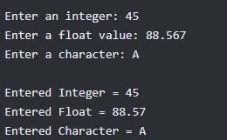

Practical: 2

Aim: To write a C program to generate the Fibonacci series up to n terms.

#include <stdio.h>
int main()
{
int n, i;
int a = 0, b = 1, c;
printf("Enter the number of terms: ");
scanf("%d", &n);
printf("Fibonacci Series: ");
for(i = 1; i <= n; i++)
{
printf("%d ", a);
c = a + b;
a = b;
b = c;
}
return 0;
}

Output :

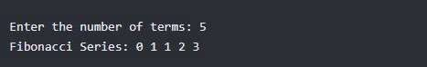

Practical: 3

Aim: To study and demonstrate different operators and expressions used in the C programming language.

#include <stdio.h>

int main()
{
int a, b;

printf("Enter two integers: ");
scanf("%d %d", &a, &b);

// Arithmetic
printf("\n--- Arithmetic Operators ---");
printf("\nAddition: %d", a + b);
printf("\nSubtraction: %d", a - b);
printf("\nMultiplication: %d", a * b);
printf("\nDivision: %d", a / b);
printf("\nModulus: %d", a % b);

// Relational
printf("\n\n--- Relational Operators ---");
printf("\nEqual: %d", a == b);
printf("\nNot Equal: %d", a != b);
printf("\nGreater: %d", a > b);
printf("\nLess: %d", a < b);

// Logical
printf("\n\n--- Logical Operators ---");
printf("\nAND (a>b && a!=b): %d", (a > b && a != b));
printf("\nOR (a>b || a<b): %d", (a > b || a < b));
printf("\nNOT (!a): %d", !a);

// Assignment
printf("\n\n--- Assignment Operators ---");
int c = a;
c += b;
printf("\nAfter c += b: %d", c);

// Increment / Decrement
printf("\n\n--- Increment / Decrement ---");
printf("\nPre-increment a: %d", ++a);
printf("\nPre-decrement b: %d", --b);

return 0;
}

Output :

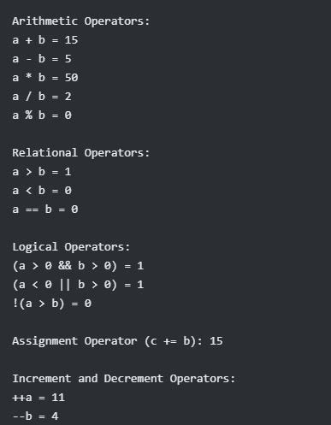

Practical: 4

Aim: To study and demonstrate the use of conditional statements and branching in the C programming language.

#include <stdio.h>

int main()
{
int num, marks, choice;

printf("Enter a number: ");
scanf("%d", &num);

printf("Enter marks (0-100): ");
scanf("%d", &marks);

printf("\n--- IF Statement ---");
if(num > 0)
{
printf("\nNumber is Positive");
}

printf("\n\n--- IF-ELSE ---");
if(num % 2 == 0)
printf("\nEven Number");
else
printf("\nOdd Number");

printf("\n\n--- ELSE-IF LADDER ---");
if(marks >= 90)
printf("\nGrade: A+");
else if(marks >= 75)
printf("\nGrade: A");
else if(marks >= 60)
printf("\nGrade: B");
else if(marks >= 40)
printf("\nGrade: C");
else
printf("\nFail");

printf("\n\n--- NESTED IF ---");
if(num > 0)
{
if(num < 100)
printf("\nNumber is Positive and less than 100");
else
printf("\nNumber is Positive but greater than 100");
}
else
{
printf("\nNumber is Negative or Zero");

}

printf("\n\n--- SWITCH CASE ---");
printf("\nEnter choice (1-3): ");
scanf("%d", &choice);

switch(choice)
{
case 1:
printf("\nYou selected Addition");
break;

case 2:
printf("\nYou selected Subtraction");
break;

case 3:
printf("\nYou selected Multiplication");
break;

default:
printf("\nInvalid Choice");
}

return 0;
}

Output :

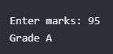
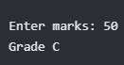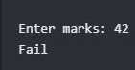

Practical: 5

Aim: To study and implement different looping statements in the C Programming Language using a C program.

#include <stdio.h>

int main() {
int i, n, sum = 0;

// FOR LOOP
printf("FOR LOOP:\n");
for(i = 1; i <= 5; i++) {
printf("%d ", i);
}

// WHILE LOOP
printf("\n\nWHILE LOOP:\n");
i = 1;
while(i <= 5) {
printf("%d ", i);
i++;
}

// DO-WHILE LOOP
printf("\n\nDO-WHILE LOOP:\n");
i = 1;
do {
printf("%d ", i);
i++;
} while(i <= 5);

// SUM OF N NUMBERS
printf("\n\nEnter a number: ");
scanf("%d", &n);

for(i = 1; i <= n; i++) {
sum = sum + i;
}

printf("Sum of first %d natural numbers = %d\n", n, sum);

return 0;
}

Output :

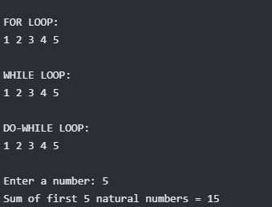

Practical: 6

Aim: To study and demonstrate the working of one-dimensional arrays in the C programming language.

#include <stdio.h>

int main() {
int arr[5], i;

// Input elements
printf("Enter 5 elements:\n");
for(i = 0; i < 5; i++) {
scanf("%d", &arr[i]);
}

// Display elements
printf("The array elements are:\n");
for(i = 0; i < 5; i++) {
printf("%d ", arr[i]);
}

return 0;
}

Output :

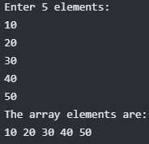

Practical: 7

Aim: To study and demonstrate the working of two-dimensional arrays in C programming by performing basic operations such as input, storage, and display of matrix elements.

#include <stdio.h>

int main() {
int rows, cols;

printf("Enter number of rows and columns: ");
scanf("%d %d", &rows, &cols);

int matrix[rows][cols];

printf("Enter elements of matrix:\n");

// Input matrix elements
for(int i = 0; i < rows; i++) {
for(int j = 0; j < cols; j++) {
scanf("%d", &matrix[i][j]);
}
}

// Display matrix
printf("The matrix is:\n");

for(int i = 0; i < rows; i++) {
for(int j = 0; j < cols; j++) {
printf("%d ", matrix[i][j]);
}
printf("\n");

}

return 0;
}

Output :

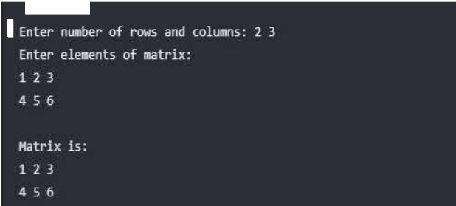

Practical: 8

Aim: To study and demonstrate the working of strings in C programming using basic string operations such as input, output, length calculation, and copying.

#include <stdio.h>
#include <string.h>

int main() {
char str1[100], str2[100];

// Input string
printf("Enter first string: ");
fgets(str1, sizeof(str1), stdin);

// Removing newline character
str1[strcspn(str1, "\n")] = '\0';

// Copying string
strcpy(str2, str1);

// Displaying strings
printf("\nOriginal String: %s\n", str1);
printf("Copied String: %s\n", str2);

// Length of string
printf("Length of string: %lu\n", strlen(str1));

return 0;
}

Output :

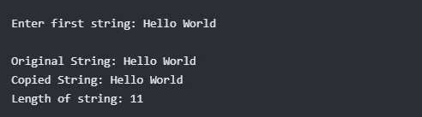

Practical: 9

Aim: To study and implement user-defined functions in C programming and understand how they improve modularity and code reusability.

#include <stdio.h>

// Function to calculate sum
int add(int a, int b) {
return a + b;
}

// Function to calculate multiplication
int multiply(int a, int b) {
return a * b;
}

int main() {
int num1, num2;
int sum, product;

printf("Enter two numbers: ");
scanf("%d %d", &num1, &num2);

// Calling user-defined functions
sum = add(num1, num2);
product = multiply(num1, num2);

printf("Sum = %d\n", sum);
printf("Product = %d\n", product);

return 0;
}

Output :

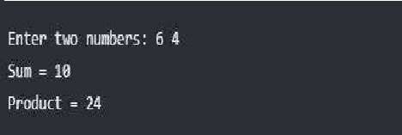

Practical: 10

Aim: To demonstrate Call by Value and Return by Value in C programming.

#include <stdio.h>

void show(int x) {
x = x + 10;
printf("Inside function: %d\n", x);
}

int main() {
int a = 5;

show(a);

printf("Hello\n");

return 0;
}

Output :

